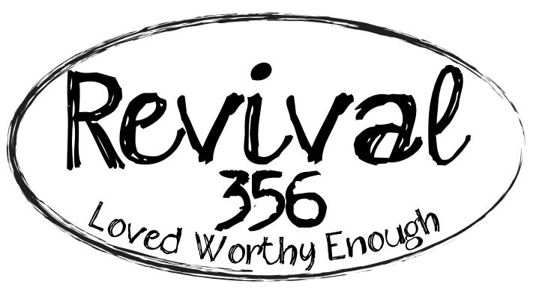

For more information:
Gretchen Howard at
Iron Skillet Media
828-231-3594
gretchen@ironskilletmedia.com
Signpost Saturdays at Revival 356 -- The Last Saturday of Each Month at Retreat Sanctuary in Ball Ground, Georgia
Signpost Saturday Four on April 29: “I am Present; I Practice the Discipline of Noticing MIracles and the Unfolding of God Everywhere.”

Ball Ground, GA (April 29, 2023) -- Vikki Fraker describes her farm, Revival 356, as stepping off the world’s rhythm and into God’s rhythm. About an hour north of Atlanta in rural Ball Ground, Georgia, Revival 356 feels eons away from the bustle of the city. A retreat sanctuary serving individuals and groups, Revival 356 offers life coaching, book studies, group and solo retreats, art workshops, yoga classes and more. Through nature, art and animals, the purpose of Revival 356 is to revive the human spirit.
On the last Saturday of every month, Revival 356 offers a group discussion of one of the farm’s 12 spiritual principles led by Vikki called “Signpost Saturdays,” 9-10:30 AM. The gatherings take place in the farm’s barn and are followed by an optional one-hour yoga class in Revival 356’s outdoor chapel, weather permitting. April’s Signpost Saturday takes place on Saturday, April 29 with the discussion of Signpost Four: “I am present, I practice the discipline of noticing miracles and the unfolding of God everywhere. This is the rhythm of His grace.”
Vikki and her husband, Eric, purchased the farm in 2012 with a dated house and an old barn. Now, both the house and the barn are transformed with Vikki and Eric’s skill and handiwork - the one-story magazine-worthy farmhouse is Vikki and Eric’s home, and “the barn” is the center of the magic of Revival 356.
The barn, with a brand new addition in the works, is a big, open, warm space. A long table stretches across one side; chairs, couches, rockers and blankets circle on the other - areas intended for gathering. Books and art supplies line the walls - growth and creativity are encouraged here. A wood stove heats the barn in the winter, and large ceiling fans circulate the country air in the summer. Chickens, dogs, sheep, goats, horses and a llama roam the property. One can explore by foot or one of the farrm’s RTVs and head down to “the holler” or visit the one-room creekside cabin or the open chapel and yoga platform.
“Revival 356 was created as a safe space for people to connect with the deepest parts of their being and to find out what brings them joy,” says Vikki. “Our way of doing that is through animals, art and nature. Revival 356 offers many opportunities for women and men to come out and rest and restore. We want people to experience a slower, more intentional pace and feel the presence of stillness within themselves.”
Vikki has a compassionate, non-judgemental approach to coaching and encourages people to embrace who they truly are. Her past struggles enable her to shift her focus from her external, physical self to her internal, spiritual self, and she helps others do the same.
She shares her continued journey of therapy, Alcoholics Anonymous and other 12 step recovery groups (CODA Codependent Anonymous and EDA Eating Disorders Anonymous and Celebrate Recovery). She is a certified Life Coach through Coach U’s Core Essential Program that is accredited by The International Coaching Federation. She regularly studies and leads group studies around the works of Wayne Dyer, Eckhart Tolle, Brene Brown and others.
To Attend Signpost Saturday Four:
Signpost Saturdays are adult discussions designated as quiet and holy time. Please leave distractions at home. Each discussion begins promptly at 9 AM with meditation. To attend Signpost Four on April 29, please RSVP on the Facebook event page or email Vikki at vikki@revival356.com.

Remaining 2023 Signpost Saturday dates:
Signpost Four: I am present, I practice the discipline of noticing miracles and the unfolding of God everywhere. This is the rhythm of His grace.
April 29, 2023
Signpost Five: I allow rather than interfere. Acceptance of what is. In all things I give thanks. ~ 1 Thessalonians 5:18 and Eckhart Tolle
May 27, 2023
Signpost Six: I can’t give what I don’t have. Love, Kindness, and Compassion start with me.
June 24, 2023
Signpost Seven: The only way out is through. ~ Robert Frost
July 29, 2023
Signpost Eight: Spot it, you got it. (Many are credited with saying this, Vikki first heard it in an Alcoholics Anonymous meeting)
August 26, 2023
Signpost Nine: I speak my truth from a place of love.
September 30, 2023
Signpost Ten: There is an inner child in each of us that wants to be seen, heard, acknowledged, and encouraged. ~ John Bradshaw
October 28, 2023
Signpost Eleven: Be still and Know that I am God. ~ Psalm 46:10
November 25, 2023
Signpost Twelve: I am loved. I am Worthy. I am Enough. ~ Revival 356’s mantra
December 30, 2023
About Revival 356
Revival 356 welcomes people of all faiths and cultures. Revival 356 is a farm retreat created by Vikki and Eric Fraker to serve those who are in need of renewal and refreshment through nature, art and animals. Its mission is to be a sanctuary where the soul is reminded of its worth and where people are awakened to a life of purpose and presence by remembering all God created them to be. The space may be rented for private retreats and groups. To schedule an individual or group life coaching session with Vikki, email vikki@revival356.com. For upcoming events and more information, visit www.revival356.com or www.facebook.com/revival356. Vikki has a new book published this year, Reconnecting to the Little Girl Within; and a virtual platform of the farm, Farm 2 Souls. Revival 356 is located at 230 King Lane, Ball Ground, GA. For more information, visit www.revivial356.com.
###

